**DEFENCE SERVICES ACADEMY**

**DEPARTMENT OF COMPUTER SCIENCE**

**IMPLEMENTATION OF AN AUTOMATED DYNAMIC WEAPON RANGE VISUALIZATION AND ENGAGAEMENT PLANNING FOR MILITARY TACTICAL SUPPORT SYSTEM USING GEOSPATIAL DATA**

**BY**

**AUNG NYI NYI MIN**

**M.C.Sc Thesis**

**MARCH, 2025**

**PYIN OO LWIN**

**DEFENCE SERVICES ACADEMY**

**DEPARTMENT OF COMPUTER SCIENCE**

**IMPLEMENTATION OF AN AUTOMATED DYNAMIC WEAPON RANGE VISUALIZATION AND ENGAGAEMENT PLANNING FOR MILITARY TACTICAL SUPPORT SYSTEM USING GEOSPATIAL DATA**

By

Captain AUNG NYI NYI MIN

A THESIS

SUBMITTED TO THE DEFENCE SERVICES ACADEMY

IN FULFILMENT OF THE REQUIREMENTS

FOR THE DEGREE OF

MASTER OF COMPUTER SCIENCE

(M.C.Sc)

MARCH, 2025

PYIN OO LWIN

**DEFENCE SERVICES ACADEMY**

This is to certify that we have examined, and recommend to the supervision committee for the M.C.Sc Program for acceptance the thesis entitled **“IMPLEMENTATION OF AN AUTOMATED DYNAMIC WEAPON RANGE VISUALIZATION AND ENGAGAEMENT PLANNING FOR MILITARY TACTICAL SUPPORT SYSTEM USING GEOSPATIAL DATA ”**, submitted by**Captain Min Htike Oo,** Roll No**. CS-10 (March, 2025)** in fulfillment of the requirements for the degree of Master of Computer Science.

**Board of Examiners:**

1. Lt.Col.Phone Naing

Professor

Department of Computer Science ---------------------------Defence Services Academy (Chairman)

1. Major Hein Naing

Assistant Lecturer

Department of Computer Science ---------------------------Defence Services Academy (Supervisor)

1. Major Aung Myo Thu

Assistant Lecturer

Department of Computer Science ---------------------------Defence Services Academy (Member)

1. Major Yar Zar Doe

Assistant Lecturer

Department of Computer Science ---------------------------Defence Services Academy (Member)

1. Dr. Nyo Nyo Yee

Professor/ Head

Department of Information Science --------------------------

University of Technology (External Examiner)

(Yatanarpon Cyber City)

1. Lt.Col. Myat Nyein Moe

Lecturer

Department of Information Technology --------------------------Defence Services Technological Academy (External Examiner)

**DEFENCE SERVICES ACADEMY**

**DEPARTMENT OF COMPUTER SCIENCE**

**IMPLEMENTATION OF AN AUTOMATED DYNAMIC WEAPON RANGE VISUALIZATION AND ENGAGAEMENT PLANNING FOR MILITARY TACTICAL SUPPORT SYSTEM USING GEOSPATIAL DATA**

**BY**

**AUNG NYI NYI MIN**

**Approved By**

|  |  |
| --- | --- |
| **Supervisor** | **Co-Supervisor** |
| **Lieutenant Colonel Zar Nay Lin** |  |
| **PHD (Computer Science)** |  |
| **Lecturer** |  |
| **Department of Computer Science** |  |

**March, 2025**

# ACKNOWLEDGEMENTS

I would like to express my profound gratitude to **Major General Soe Myat Htut**, Commandant of Defence Services Academy for allowing me to attend the Master of Computer Science, program at Defence Services Academy.

I would special thanks to Rector of Defence Services Academy, **Brigadier General Thein Lwin**, for his kind permission and encouragement for my Master Degree in Computer Science.

I wish to extend my thanks to person, **Lieutenant Colonel Soe Win Myint**, Head of Department of Computer Science at Defence Services Academy, for his close support in doing thesis work, attending seminars, giving valuable advices and guidance for preparation of this thesis.

I am highly indebted to **Lieutenant Colonel Zar Nay Lin,** who is responsible for Master of Computer Science at Defence Services Academy, for his immense patience and providing an incredible amount of guidance.

I must particularly express my thankfulness to my coaches, **Lieutenant Colonel Zar Nay Lin**, Lecturer and supervisor, Department of Computer Science at Defence Services Academy, for valuable advices, their close supervision, kind guidance and support and cooperation of master degree program, and I realized the valuable suggestions, understanding and generous encouragements during a long period of study for thesis paper.

Last but not least, many thanks to all persons who directly and indirectly contributed toward the completion of this thesis.

# ABSTRACT

The efficient planning and execution of military operations rely heavily on accurate situational awareness and decision support systems. This thesis presents the design and implementation of an Automated Dynamic Weapon Range Visualization and Engagement Planning System (ADWRVEPS) for military tactical support, leveraging advanced geospatial data integration and computational techniques. The system addresses the critical challenges of real-time range assessment, terrain analysis, and engagement strategy optimization, enhancing operational readiness and precision in mission-critical scenarios.

The proposed system utilizes geospatial data to dynamically model weapon engagement zones, factoring in terrain elevation, obstacles, atmospheric conditions, and weapon-specific performance parameters. A combination of Geographic Information System (GIS) frameworks and advanced algorithms for spatial analysis enables real-time visualization of weapon ranges, highlighting viable target zones and blind spots. The visualization integrates seamlessly with 3D terrain models, offering an intuitive, high-fidelity representation of the battlespace.

To support strategic planning, the system employs optimization techniques, such as genetic algorithms and graph-based pathfinding, to recommend optimal engagement strategies. These strategies consider factors like minimizing collateral damage, maximizing coverage, and ensuring operator safety. The architecture of the system is modular, featuring a robust data ingestion pipeline for geospatial datasets, a real-time analytics engine, and an interactive user interface designed for operational usability in field conditions.

Performance evaluation demonstrates the system’s effectiveness in diverse operational scenarios, including urban combat, open terrain, and mountainous environments. The system’s ability to adapt to changing tactical requirements, such as the deployment of new weapon systems or updated battlefield intelligence, underscores its value as a versatile and scalable tool for modern military applications.

This research contributes to the advancement of geospatially-driven tactical decision-making systems, offering a practical, automated solution that bridges the gap between theoretical geospatial analytics and real-world military operations. The insights and methodologies presented in this work have the potential to revolutionize engagement planning and enhance the precision and efficacy of military missions.

**Keywords:** Automated Visualization, Weapon Range Modeling, Engagement Planning, Geospatial Data, Military Tactical Support, GIS in Military Applications, Dynamic Terrain Analysis, Operational Decision Support, Real-Time Systems, Optimization Algorithms, 3D Battlefield Visualization, Situational Awareness, Tactical Engagement Strategy, Spatial Analytics, Defense Technology

# TABLE OF CONTENTS

**Page**

ACKNOWLEDGEMENTS i

ABSTRACT ii

TABLE OF CONTENTS iv

LIST OF ABBREVIATIONS viii

LIST OF FIGURES ix

CHAPTER 1 1

INTRODUCTION 1

1.1 Problem Statement 2

1.2 Motivation 4

1.3 Aim of Thesis 5

1.4 Objective of Thesis 5

1.5 Overview of the System 5

1.6 Organization of Thesis 6

CHAPTER 2 7

BACKGROUND KNOWLEDGE 7

2.1 Flutter for Android Application 7

2.1.1 The advantages of Flutter 8

2.2 Geographic information system (GIS) 8

2.2.1 GIS for Military Applications 10

2.2.2 GIS Data Models and Techniques 10

2.2.3 GIS and Real-Time Data Integration 11

2.3 Military Grid Reference System (MGRS) 12

2.3.1 Structure of MGRS Coordinates 13

2.3.2 Advantages of MGRS for Military Applications 15

2.3.3 Applications of MGRS in Military Operations 16

2.4 LatLang (Latitude, Longitude) to MGRS Conversion 16

2.4.1 The Need for LatLon to MGRS Conversion 17

2.4.2 Conversion Process 17

2.4.3 Conversion from Latitude/Longitude to MGRS 18

2.5 Tactical Decision Support System (TDSS) 19

2.5.1 Key Components of TDSS 20

2.5.2 Applications of TDSS in Military Operations 21

2.5.3 Advantages of TDSS 22

2.5.4 Future of TDSS 22

2.6 Bearing Calculation on a Map from One Place to Another 23

2.6.1 Convert to Degrees 23

2.6.2 Convert to Mils 24

2.7 Map Caching For Online and Offline Use 25

2.7.1 Purpose of Map Caching 26

2.7.2 Types of Map Caching 26

2.7.3 Implementation of Map Caching 26

2.7.4 Online and Offline Use Cases 27

2.7.5 Challenges and Solutions 28

2.7.6 Tools and Libraries for Map Caching 28

2.8 Lanchester’s Square Law for decision making Feedback 29

2.8.1 Overview of Lanchester’s Square Law 29

2.8.2 Application in Tactical Decision-Making 30

2.9 Summary 30

CHAPTER 3 32

SYSTEM DESIGN AND IMPLEMENTATION 32

3.1 Proposed System Design of Android Application 32

3.2 Overall Design of the System 33

3.3 Detail Design for Admin 34

3.4 Detail Design for User 35

3.5 Proposed System Design for Database 36

3.6 Distance Calculation from One Place to Another using Haversine Formula 37

3.6.1 Example: Distance Calculation from Pyin Oo Lwin to Mandalay 37

3.7 Bearing Calculation from One Place to Another 38

3.7.1 Example: Bearing Calculation from Pyin Oo Lwin to Mandalay 38

3.8 Weapon Firing Solutions for Two Motor Guns (MA-7, MA-8) 39

3.8.1. General Formula for Firing Solutions 39

3.8.1. Example Calculations for 2000 Meters for MA-7 40

3.8.1. Example Calculations for 2000 Meters for MA-7 in Flutter 41

3.9 Latitude/ Longitude Coordinate to MGRS Conversion 42

3.9.1 Latitude/ Longitude Coordinate to MGRS Conversion in Flutter 43

3.10 Implementation 46

3.11 Summary 49

CHAPTER 4 51

CONCLUSION 51

4.1 Benefits of the System 51

4.2 Limitations of the System 52

4.3 Further Extensions 53

REFERENCES 55

APPENDIX/APPENDICES 57

# LIST OF ABBREVIATIONS

API Application Programming Interface

ASCII American Standard Code for Information Interchange

BMP Bit Map

CMYK Cyan, Magenta, Yellow, Key (black)

DCT Discrete Cosine Transform

DFT Discrete Fourier Transform

GIF Graphics Interchange Format

JPEG Joint Photographic Expert Group

LSB Least Significant Bit

MSB Most Significant Bit

PNG Portable Network Graphic

RLE Run-Length Encoding

TIFF Tagged Image File Format

WT Wavelet Transform

# LIST OF FIGURES

**Figure Page**

2.1RGB Color Cube 11

2.2RGB Levels of this Selected Color 12

2.3Decimal Equivalents 15

2.4RGB Color Model 16

2.5Encrypt into Cover Image 17

2.6Decrypt from Stego Image 17

2.7Columnar Transpositions 22 2.8 Tableau Form of Keyword Columnar Transposition 23

2.9Keyword Columnar Transpositions 24

2.10Cipher Text 24

2.11Plain Text 25

2.12Formation of a RGB Image and a BW Image 25

3.1Proposed System Design of Android Application 32

3.2System Design of Encryption 33

3.3 System Design of Decryption 34

3.4Create New Account Form 34

3.5Login to Continue Form 35

3.6Encode and Decode Home Page 36

3.7State of Chosen an Image 37

3.8Write Plain Texts in Enter Your Text Box 38

3.9Chooses a Keyword in Generate Keys 39

3.10Choose the Image to Decrypt 40

3.11 Insert Auto Generate Keys and Click “Decode” to Decrypt 41

3.12Click “Decode” Will Get Original Plain Text 42

List of Figures (Continued)

3.13Add User in Chatting Form 43

3.14 More Part of Application 44

# CHAPTER 1

# INTRODUCTION

In modern military operations, the need for precise and effective tactical decision-making has become more critical than ever. As technological advancements reshape the battlefield, traditional methods of engagement planning and weapon range visualization are proving insufficient to address the complexities of contemporary conflicts. The integration of geospatial data and automated decision-support systems offers an unprecedented opportunity to enhance situational awareness, optimize engagement strategies, and improve operational outcomes.

Military operations often occur in dynamic and unpredictable environments, where factors such as terrain, weather conditions, and the performance characteristics of weapon systems must be carefully analyzed. Accurate and real-time visualization of weapon engagement ranges is crucial for identifying strategic opportunities, minimizing risks, and reducing collateral damage. However, existing approaches to engagement planning are often static, time-consuming, and reliant on manual interpretation of data, leading to potential inefficiencies and vulnerabilities.

This thesis proposes the development of an *Automated Dynamic Weapon Range Visualization and Engagement Planning System* (ADWRVEPS), designed to address these challenges by leveraging geospatial data and advanced computational techniques. The system integrates Geographic Information System (GIS) technology with real-time analytics to dynamically model and visualize weapon engagement zones, accounting for critical variables such as terrain elevation, obstacles, and atmospheric conditions. Additionally, it incorporates optimization algorithms to generate actionable engagement strategies, enabling military planners to make informed decisions with greater speed and accuracy.

The primary contributions of this research are threefold. First, it introduces a novel framework for dynamic weapon range visualization that offers a high-fidelity, interactive representation of the battlespace. Second, it develops a suite of engagement planning tools that optimize weapon deployment based on mission objectives and environmental constraints. Finally, it evaluates the system’s performance in simulated operational scenarios, demonstrating its scalability, adaptability, and potential to enhance the effectiveness of military operations.

By bridging the gap between geospatial analytics and real-world tactical decision-making, this research aims to contribute to the development of next-generation military support systems. The insights gained from this work have far-reaching implications, not only for defense applications but also for broader fields such as disaster management and homeland security, where dynamic situational awareness and precise planning are equally critical.

## 1.1 Problem Statement

Effective military operations rely on precise tactical planning, particularly when deploying weapon systems in complex and dynamic environments. The ability to visualize weapon engagement ranges and develop optimized engagement strategies is critical for ensuring mission success, minimizing collateral damage, and maximizing resource efficiency. However, existing methods for weapon range visualization and engagement planning face several significant limitations:

1. **Static and Manual Processes**: Traditional approaches to engagement planning often involve manual analysis of static maps and outdated information. These methods are time-consuming and prone to human error, reducing the agility of tactical decision-making.
2. **Lack of Real-Time Adaptability**: Modern battlefields are highly dynamic, with rapidly changing conditions such as terrain, enemy movements, and environmental factors. Existing systems fail to provide real-time updates, leading to delays in strategy adjustments.
3. **Inadequate Integration of Geospatial Data**: While geospatial data has become increasingly accessible, its integration into military decision-making tools remains underutilized. Current systems lack the capability to process and analyze complex geospatial datasets effectively, resulting in limited situational awareness.
4. **Limited Visualization Capabilities**: Current visualization tools are often simplistic, failing to provide detailed, interactive, and intuitive representations of weapon engagement zones. This hampers the ability of military personnel to quickly assess and respond to tactical opportunities.
5. **Inefficient Engagement Strategies**: The absence of automated optimization algorithms in planning systems leads to suboptimal deployment of weapon systems. This inefficiency can result in unnecessary risks, resource wastage, and missed operational objectives.

The convergence of these limitations underscores the need for an advanced solution that combines dynamic geospatial data analysis, real-time visualization, and automated engagement planning. Without such a system, military operations remain constrained by outdated methods, unable to fully leverage modern technological advancements for tactical superiority.

That seeks to address these challenges by developing an “Automated Dynamic Weapon Range Visualization and Engagement Planning System” (ADWRVEPS) that leverages geospatial data, advanced algorithms, and state-of-the-art visualization techniques to transform military tactical support and decision-making.

## 1.2 Motivation

Modern military operations are increasingly conducted in complex and dynamic environments, where success depends on the ability to make informed and timely decisions. Traditional methods of tactical planning and weapon deployment, rooted in static maps and manual calculations, are no longer sufficient to address the multifaceted challenges of contemporary battlefields. The integration of advanced geospatial analytics and real-time data processing offers a transformative opportunity to enhance situational awareness, enabling commanders to visualize the battlefield with unprecedented clarity. This motivation stems from the urgent need to bridge the gap between available technological advancements in Geographic Information Systems (GIS), computational modeling, and decision support, and their practical application in tactical military scenarios. A system that dynamically adapts to terrain, environmental factors, and weapon capabilities can eliminate operational inefficiencies, streamline resource allocation, and provide actionable insights to decision-makers.

Beyond the immediate military context, this research is motivated by the broader implications of leveraging cutting-edge technologies for precision and ethical considerations. Modern warfare emphasizes minimizing collateral damage, ensuring operational precision, and adapting rapidly to unpredictable conditions. By automating weapon range visualization and engagement planning, this work seeks to reduce human error, enhance safety, and support scalable solutions applicable across diverse scenarios such as disaster response and homeland security. The development of a robust, adaptable system not only promises to revolutionize military tactics but also contributes to the evolution of intelligent decision-making tools that are critical for addressing both current and future challenges in multidimensional operational environments.

## 1.3 Aim of Thesis

The aim of this thesis is to develop an automated system for dynamic weapon range visualization and engagement planning that leverages geospatial data and advanced computational techniques to enhance military tactical decision-making and operational efficiency.

## 1.4 Objective of Thesis

The objectives of this thesis are as follows:

1. To develop a geospatial data processing framework that integrates various sources of geospatial and military data
2. To design an automated tool for visualizing weapon range dynamics, considering the effects of real-time data inputs
3. To develop a visualization module based on weapon specifications
4. To create an engagement planning module that supports military personnel in determining optimal weapon usage strategies

## 1.5 Overview of the System

The proposed system, an *Automated Dynamic Weapon Range Visualization and Engagement Planning System* (ADWRVEPS), is a cutting-edge solution designed to enhance tactical decision-making in military operations. It integrates geospatial data, computational modeling, and real-time analytics to provide a comprehensive platform for visualizing weapon engagement ranges and generating optimized engagement strategies. The system’s architecture is modular, comprising distinct yet interdependent components that collectively deliver seamless functionality and adaptability in dynamic operational environments.

At its core, the system features a Geospatial Data Processing Engine that ingests and analyzes multi-source geospatial datasets, including terrain maps, elevation models, and environmental conditions. This engine drives the Dynamic Visualization Module, which renders 3D, high-fidelity representations of weapon engagement zones. The visualization dynamically adjusts to changes in battlefield conditions, such as weapon parameters, terrain features, and atmospheric factors, providing users with an accurate and intuitive view of the operational landscape.

To support strategic planning, the Engagement Optimization Module employs advanced algorithms, such as genetic algorithms and heuristic search methods, to recommend deployment and engagement strategies. These strategies are tailored to mission-specific objectives, balancing factors like operational efficiency, safety, and collateral damage minimization. A user-friendly Decision Support Interface serves as the system’s front-end, enabling military planners to interact with the visualization and analytics in real time, facilitating rapid and informed decision-making.

The system is designed for scalability and adaptability, with a flexible architecture that allows integration with emerging technologies, such as unmanned systems and sensor networks. Furthermore, its modular design supports cross-domain applications, extending its utility beyond military operations to areas such as disaster management, homeland security, and critical infrastructure protection. This versatility underscores the system's potential as a transformative tool for real-time decision support in complex and high-stakes environments.

## 1**.6 Organization of Thesis**

This thesis consists of four chapters. Chapter 1 describes introduction, problem statement, motivation, objectives of thesis and organization of thesis. The

remaining parts are organized as follows.

Chapter 2 describes theoretical background and it explains about details of using LSB algorithm and columnar transposition method.

Chapter 3 presents the system design and implementation, system flow, use-case diagram of the system, output of the system and performance analysis.

Chapter 4 concludes the benefits, limitations, the further extensions, summary and conclusion of the thesis.

# CHAPTER 2

# BACKGROUND KNOWLEDGE

This chapter is dedicated background theory about Flutter, Geographic Information System, Military Grid Reference System (MGRS), Tactical Decision Support System (TDSS), Map Caching For online and offline use and Lanchester’s Square Law for Decision making.

## 2.1 Flutter for Android Application

Flutter is an open-source UI software development kit created by Google that enables developers to build natively compiled applications for mobile, web, and desktop from a single codebase. Initially developed for Android and iOS app development, Flutter has quickly gained popularity due to its performance, flexibility, and ease of use. Flutter uses the Dart programming language, which is optimized for fast development and high performance. The framework’s standout feature is its ability to compile directly to native code, allowing it to offer performance similar to that of native Android applications.

In the context of Android application development, Flutter provides a rich set of pre-built widgets and tools that help developers create highly customizable, responsive, and visually attractive user interfaces. Its reactive framework ensures that the UI updates automatically when the underlying data changes, making it ideal for applications that require dynamic content. Additionally, Flutter’s "hot reload" feature allows developers to see changes in real time, speeding up the development cycle and improving productivity. This is particularly useful when developing complex applications that require rapid iteration and testing.

One of the key advantages of using Flutter for Android application development is the ability to deploy to multiple platforms (Android, iOS, web) with a single codebase, reducing the overall development time and cost. Furthermore, Flutter’s robust ecosystem of plugins and packages provides easy access to device-specific APIs and third-party services, further enhancing its versatility and functionality. [1]

### 2.1.1 The advantages of Flutter

Here are some ways that Flutter stands out as a cross-platform development framework:

1. **Close-to-native performance.**Flutter uses the programming language Dart and compiles into machine code. Host devices understand this code, which ensures a fast and effective performance.
2. **Fast, consistent, and customizable rendering.**Instead of relying on platform-specific rendering tools, Flutter uses Google’s open-source Skia graphic library to render UI. This provides users with consistent visuals no matter what platform they use to access an application.
3. **Developer-friendly tools.** Google built Flutter with an emphasis on ease-of-use. With tools like hot reload, developers can preview what code changes will look like without losing state. Other tools like the widget inspector make it easy to visualize and solve issues with UI layouts.

## 2.2 Geographic information system (GIS)

A geographic information system (GIS) is a computer system for capturing, storing, checking, and displaying data related to positions on Earth’s surface. By relating seemingly unrelated data, GIS can help individuals and organizations better understand spatial patterns and relationships.

GIS technology is a crucial part of spatial data infrastructure, which the White House defines as “the technology, policies, standards, human resources, and related activities necessary to acquire, process, distribute, use, maintain, and preserve spatial data.”

GIS can use any information that includes location. The location can be expressed in many different ways, such as latitude and longitude, address, or ZIP code.

Many different types of information can be compared and contrasted using GIS. The system can include data about people, such as population, income, or education level. It can include information about the landscape, such as the location of streams, different kinds of vegetation, and different kinds of soil. It can include information about the sites of factories, farms, and schools, or storm drains, roads, and electric power lines.

With GIS technology, people can compare the locations of different things in order to discover how they relate to each other. For example, using GIS, a single map could include sites that produce pollution, such as factories, and sites that are sensitive to pollution, such as wetlands and rivers. Such a map would help people determine where water supplies are most at risk. [2]

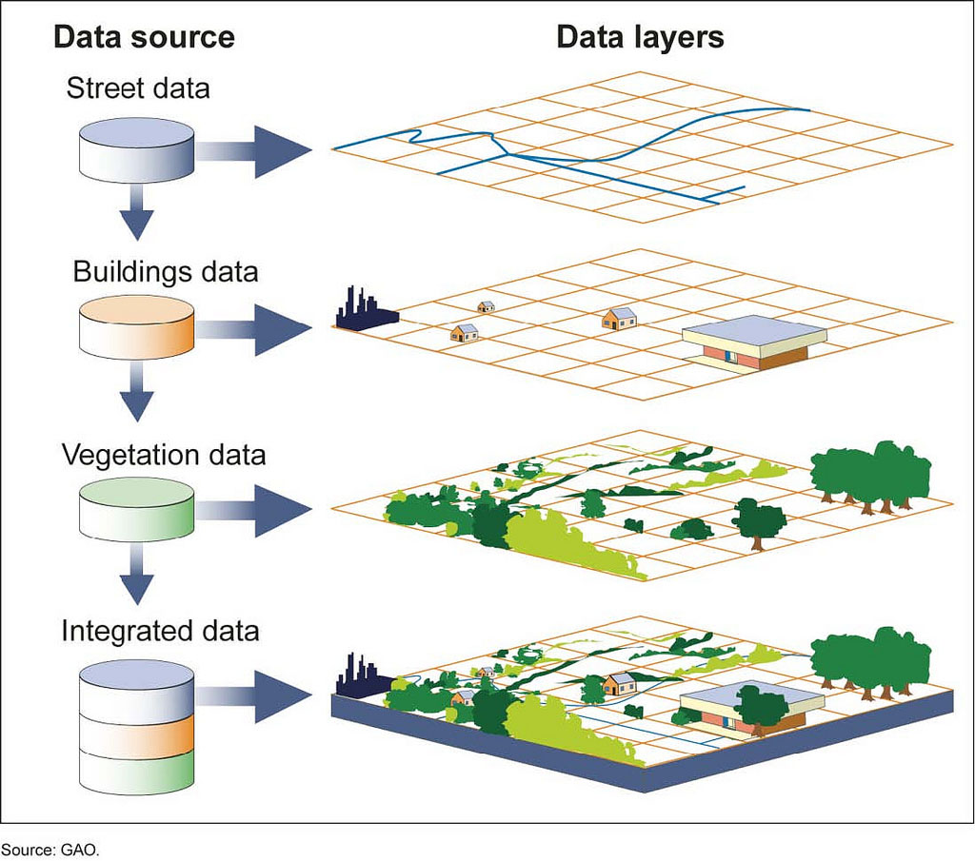

Figure 2.1 A geographic information system (GIS)

### 2.2.1 ****GIS for Military Applications****

Geographic Information Systems (GIS) have been increasingly adopted in military operations due to their ability to enhance decision-making through detailed spatial analysis and real-time data integration. In military contexts, GIS is utilized for a variety of purposes, including terrain analysis, mission planning, asset tracking, and threat assessment. By integrating geospatial data with military-specific information, such as weapon ranges, troop movements, and weather patterns, GIS provides a comprehensive platform that supports the rapid and informed execution of operations.

For example, GIS allows military strategists to conduct detailed terrain analysis, identifying high ground, potential ambush sites, and movement corridors that would be crucial for mission planning. Furthermore, GIS can be used for route optimization, minimizing risk and maximizing operational efficiency in hostile environments. It also enhances command and control by integrating real-time data, such as troop positions or sensor information, to maintain an up-to-date operational picture of the battlefield.

In addition to these tactical advantages, GIS also supports logistical operations. It helps with resource management by tracking supplies, personnel, and equipment, ensuring that assets are efficiently allocated across units. By leveraging GIS in military applications, decision-makers can make better-informed, data-driven decisions, improving mission success and reducing the likelihood of unforeseen challenges. [3]

### 2.2.2 GIS Data Models and Techniques

GIS relies on different data models and techniques for representing and analyzing spatial information. The most common data models used in GIS are vector and raster models, each serving different types of spatial data representation and analysis needs.

1. Vector Model: The vector model represents geographic features using points, lines, and polygons. This model is suitable for representing discrete features such as roads, buildings, boundaries, and other man-made or natural entities. In the context of military operations, vector data is essential for representing key features of the terrain, such as roads, rivers, and borders, as well as operational assets like military bases and strategic locations.
2. Raster Model: The raster model represents spatial data in a grid format, where each cell (or pixel) contains a value corresponding to a specific attribute, such as elevation, temperature, or land cover. Raster data is often used for continuous surfaces, such as elevation models, climate data, and satellite imagery. In military applications, raster data plays a crucial role in analyzing terrain elevation, vegetation density, and visibility, helping to assess line-of-sight for weapons and reconnaissance activities.

Other techniques within GIS include spatial analysis, which involves examining the relationships between different geographical features, and geostatistical analysis, which applies statistical methods to spatial data to identify patterns or predict future events. Techniques such as buffer analysis, overlay analysis, and network analysis are commonly used in military GIS applications to assess risks, optimize routes, and make decisions about asset deployment. [3]

### 2.2.3 GIS and Real-Time Data Integration

The integration of real-time data with GIS has revolutionized its application in dynamic environments, such as military operations, disaster management, and urban planning. Real-time data, sourced from various devices and sensors such as GPS, UAVs, and satellites, can be integrated into GIS platforms to provide up-to-date situational awareness and enhance decision-making processes. [3]

In military contexts, real-time GIS data integration is critical for operations such as troop movement tracking, battlefield surveillance, and sensor fusion. The use of real-time data allows for the continuous monitoring of changing conditions on the ground, such as enemy troop movements, weather shifts, or supply status. This integration provides military commanders with the ability to adapt rapidly to emerging threats or changes in the operational environment, improving both tactical responsiveness and strategic planning.

Real-time GIS also plays a vital role in communication between units, facilitating collaboration and information sharing in real time. For example, commanders in the field can upload positional data from mobile devices or drones to the central GIS system, providing other team members with a live, synchronized operational picture. In turn, this allows for quicker decision-making, more coordinated actions, and a higher likelihood of mission success. The ability to integrate real-time data into GIS systems also supports predictive analysis, enabling military forces to anticipate potential threats and adjust plans accordingly.

Together, these GIS capabilities enable enhanced operational effectiveness in complex, time-sensitive situations, making it an indispensable tool for modern military forces. The continued advancement of GIS technologies, particularly in the areas of real-time data integration and analysis, is expected to further solidify its role in military strategy and decision support. [3]

## 2.3 Military Grid Reference System (MGRS)

The Military Grid Reference System (MGRS) is a geocoordinate standard used by NATO and various military organizations worldwide to pinpoint locations on the Earth’s surface with high precision. MGRS is based on the Universal Transverse Mercator (UTM) coordinate system, which divides the Earth into a series of 6° longitudinal zones. Each zone is further divided into grid squares, providing an easy-to-read, compact, and standardized method for referencing geographic locations. The system is widely used in military operations for mapping, navigation, and geospatial analysis, offering a consistent and universally accepted method of specifying locations in both tactical and operational environments.

MGRS coordinates are expressed as a combination of a zone number, a grid square identifier, and numerical coordinates. The grid reference consists of two parts: the **grid zone designator** and the **easting and northing coordinates**. The grid zone designator includes a letter (A-Z, except for I and O) to indicate the latitude band and a numeric zone number to specify the longitudinal zone. For example, a complete MGRS coordinate might appear as "33TWN1234567890," where "33" represents the zone number, "T" represents the latitude band, "WN" identifies a specific grid square, and the numbers represent the precise easting and northing within that square.

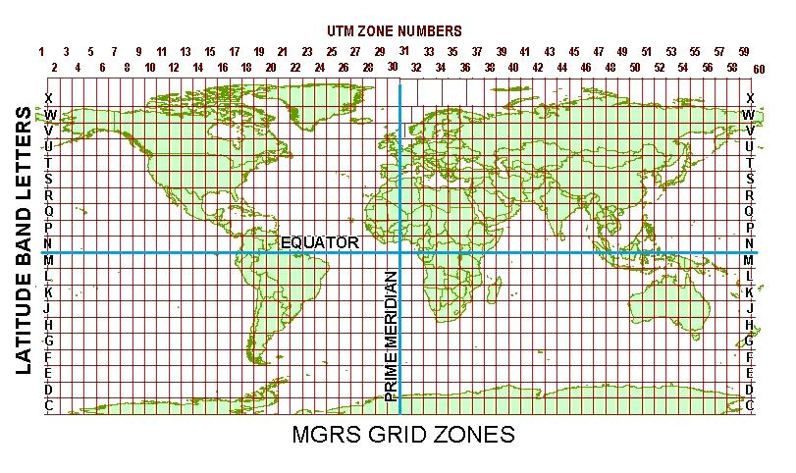

Figure 2.2 MGRS Grid Zone

### 2.3.1 ****Structure of MGRS Coordinates****

MGRS coordinates are typically structured in a hierarchical system that increases in precision as more digits are added to the reference. The general format for MGRS is as follows:

1. **Zone Number**: A two-digit number representing one of the 60 UTM zones, which span from 1 to 60, each covering 6 degrees of longitude.
2. **Latitude Band Letter**: A letter indicating the latitude zone, with the range of A to Z (excluding I and O), and each letter corresponding to a specific range of latitudes. For instance, "C" corresponds to latitudes between 80°S and 72°S, and "T" covers latitudes between 72°N and 84°N.
3. **Grid Square**: A two-letter identifier that divides each UTM zone into 100 km x 100 km grid squares. These squares are numbered from A to Z (except I and O), which increases precision and makes map reading easier.
4. **Easting and Northing**: These numbers provide the precise location within the grid square, with easting denoting the horizontal position (eastward from the origin) and northing denoting the vertical position (northward from the origin). The accuracy can be enhanced by adding more digits to these coordinates, typically up to 10 meters or even 1 meter in precision.

For example, a coordinate such as **33TWN1234567890** refers to a point located within the grid square "WN" in zone 33, with the last digits providing the specific position within that square. This system enables precise navigation, even in areas with no recognizable landmarks, such as deserts or remote mountainous regions.

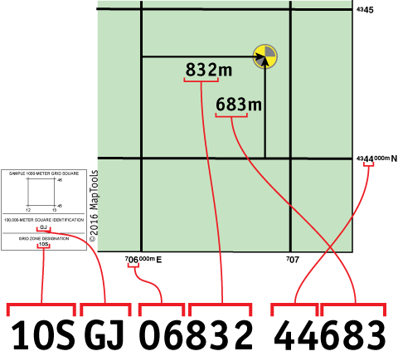

Figure 2.3 Components of MGRS

### 2.3.2 ****Advantages of MGRS for Military Applications****

MGRS provides numerous advantages for military operations, making it the preferred choice for navigation, planning, and coordination in the field:

1. **Global Standardization**: Since MGRS is a standardized system, it is used by various international military organizations, including NATO, which ensures interoperability between allied forces operating in different regions. This standardization facilitates communication and the sharing of operational data without confusion or discrepancies, even in multinational coalitions.
2. **High Precision**: MGRS coordinates can be specified with various levels of precision, from a broad zone-level reference (e.g., 1,000,000 meters) to highly detailed coordinates (down to a meter or even a centimeter in some cases). This flexibility allows for precision tailoring of location data, depending on mission requirements.
3. **Ease of Use**: The grid system used in MGRS is easier to read and work with compared to traditional latitude and longitude coordinates. MGRS simplifies the interpretation of geospatial data, especially in tactical scenarios where speed and clarity are critical.
4. **Compatibility with Mapping Tools**: MGRS is compatible with most modern mapping and navigation tools, including handheld GPS devices, digital maps, and military-specific software. This compatibility ensures that the system can be integrated into various technological platforms, enhancing operational efficiency.
5. **Efficiency in Combat Situations**: In military combat scenarios, the need for rapid communication of location data is paramount. The MGRS’s compact format makes it easier for soldiers to communicate coordinates over radio, in written reports, or in tactical discussions. This speed is crucial when coordinating movements, targeting, or support operations in fast-paced environments.

### 2.3.3 ****Applications of MGRS in Military Operations****

MGRS is essential in numerous military applications, including:

1. **Navigation and Wayfinding**: Military units rely on MGRS for tactical navigation, whether on foot, in vehicles, or using air and naval forces. Accurate coordinates allow for precise movement, ensuring that units can reach designated locations without delay.
2. **Targeting and Fire Support**: MGRS is extensively used in artillery, airstrikes, and missile targeting. By using MGRS, military planners can ensure that targets are correctly identified and engaged, minimizing the risk of friendly fire and collateral damage.
3. **Geospatial Intelligence**: The system is used to gather, process, and analyze geospatial intelligence (GEOINT), which includes terrain features, enemy positions, and infrastructure. This information is vital for mission planning and for providing commanders with a comprehensive understanding of the operational environment.
4. **Logistics and Supply Chain Management**: MGRS coordinates are crucial for managing supply routes, staging areas, and resource distribution. They ensure that logistical operations are executed efficiently and that resources are allocated to the right locations at the right time.
5. **Situational Awareness**: MGRS enables real-time situational awareness on the battlefield, providing commanders and soldiers with accurate and easily interpretable information about their surroundings, including terrain, enemy activity, and friendly force positions.

## 2.4 LatLang (Latitude, Longitude) to MGRS Conversion

The conversion of geographic coordinates from latitude and longitude (LatLon) to the Military Grid Reference System (MGRS) is a critical process in geospatial applications, particularly in military operations. Latitude and longitude are expressed in a global coordinate system that defines a location based on angular measurements from the Earth’s center, while MGRS provides a grid-based system that simplifies positional references for tactical and operational purposes. The conversion ensures that data from sources like GPS devices, which typically output LatLon coordinates, can be utilized effectively within the MGRS framework for mapping, navigation, and situational awareness.

### 2.4.1 ****The Need for LatLon to MGRS Conversion****

The LatLon coordinate system, based on the geographic grid of parallels and meridians, is versatile and universally recognized. However, it has limitations in military contexts where quick, concise, and precise communication of locations is essential. Latitude and longitude values are expressed in degrees, minutes, and seconds or decimal degrees, which can be cumbersome to interpret and relay in high-stress scenarios.

Conversely, MGRS is designed for operational simplicity, offering a grid-based approach that is compact, standardized, and easier to understand and communicate. The LatLon to MGRS conversion allows military personnel to leverage GPS technology while adhering to the MGRS standard, ensuring seamless integration across diverse systems and operational units. [5]

### 2.4.2 ****Conversion Process****

The LatLon to MGRS conversion involves several steps:

1. **Determine the UTM Zone**: Latitude and longitude coordinates are first used to identify the corresponding UTM (Universal Transverse Mercator) zone. The Earth is divided into 60 UTM zones, each spanning 6 degrees of longitude. For example, longitude 72°E would fall within UTM Zone 43.
2. **Identify the Latitude Band**: The latitude coordinate determines the latitude band, represented by letters (C to X, excluding I and O) that indicate specific ranges of latitude. For example, latitude 25°N corresponds to Band Q.
3. **Project Coordinates into UTM**: The LatLon values are projected into the UTM coordinate system using mathematical formulas that convert angular measurements into linear coordinates (easting and northing). This step considers the reference ellipsoid (typically WGS84) and the zone-specific parameters to account for distortions.
4. **Apply MGRS Grid Square Designation**: The UTM coordinates are further divided into 100 km x 100 km grid squares, each designated by a two-letter combination unique to the zone.
5. **Add Precision Digits**: The final step involves adding easting and northing digits to specify the exact location within the grid square. The number of digits depends on the desired precision (e.g., 1 meter, 10 meters, or 100 meters).

For example, the LatLon coordinates (25.2048°N, 55.2708°E) might be converted to an MGRS coordinate like **40RWR1234567890**, where "40" is the UTM zone, "R" is the latitude band, "WR" is the grid square, and the numerical values represent precise easting and northing positions. [5]

### ****2.4.3 Conversion from Latitude/Longitude to MGRS****

The conversion from latitude and longitude to the MGRS coordinate system involves the following steps:

1. **Datum and Ellipsoid Definition:** The input lat/lng coordinates are referenced to a specific geodetic datum (e.g., WGS84). This datum defines the shape of the Earth through its ellipsoid parameters.
2. **Determine UTM Zone:** The UTM zone is calculated based on longitude (λ):



Where Z is the UTM zone number, λ is longitude in degrees, and ⌊x⌋ denotes the floor function.

1. **Project to UTM Coordinates:** The latitude (ϕ) and longitude (λ) are projected to UTM coordinates using the transverse Mercator projection. Key equations include:

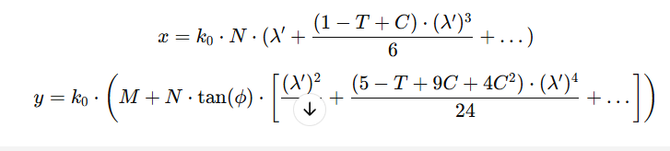

Here:

* 1. λ: longitude relative to the central meridian of the UTM zone
  2. k0​: scale factor (commonly 0.9996)
  3. N: radius of curvature in the prime vertical
  4. T: square of the tangent of latitude
  5. C: ellipsoidal parameter
  6. M: meridional arc length

1. **Determine MGRS Grid Square:** Divide the UTM coordinates into 100,000-meter grid squares. Identify the alphanumeric grid square based on the calculated Easting and Northing.
2. **Apply Latitude Band and Precision:** The latitude band (letters) is determined based on the latitude (ϕ), and the coordinate is rounded to the desired precision (e.g., 1 m, 10 m, 100 m).
3. **Final MGRS Representation**: An MGRS coordinate has the structure:

MGRS=Z⋅Latitude Band⋅Grid Square⋅Easting⋅Northing, where Z is the UTM zone number, and the other components are calculated as described. [6]

## 2.5 Tactical Decision Support System (TDSS)

A Tactical Decision Support System (TDSS) is a specialized class of decision-support tools designed to assist military planners and commanders in making informed and timely decisions during operations. TDSS integrates advanced technologies, data analytics, and geospatial information to provide actionable insights, streamline operational planning, and enhance situational awareness in dynamic and high-stakes environments. By leveraging real-time data, predictive modeling, and simulation capabilities, TDSS serves as a critical component in modern military operations, enabling rapid adaptation to changing conditions on the battlefield.

TDSS operates by aggregating and processing data from multiple sources, such as satellite imagery, sensor networks, unmanned aerial vehicles (UAVs), and human intelligence. This data is analyzed to generate comprehensive visualizations and recommendations that help commanders evaluate different courses of action, assess risks, and optimize resource allocation. Unlike traditional decision-making processes, which can be time-consuming and prone to errors, TDSS provides a structured and data-driven approach that ensures accuracy and efficiency. [7]

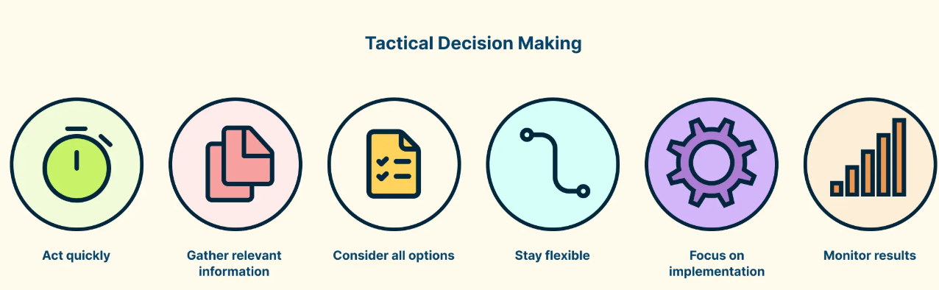

Figure 2.4 Tactical Decision-Making Process

### 2.5.1 ****Key Components of TDSS****

1. **Data Integration and Fusion**: TDSS collects data from various sources, including geospatial databases, weather forecasts, and reconnaissance systems. The system uses advanced data fusion techniques to combine disparate data streams into a cohesive operational picture, reducing information overload and improving clarity.
2. **Geospatial Analysis**: One of the core features of TDSS is its ability to analyze spatial data. By integrating Geographic Information Systems (GIS), the system provides detailed terrain analysis, route optimization, and visibility assessments, which are essential for mission planning and execution.
3. **Simulation and Modeling**: TDSS incorporates simulation tools to model potential scenarios and predict outcomes based on different variables. This capability allows commanders to evaluate the impact of their decisions before implementing them, minimizing risks and ensuring mission success.
4. **Real-Time Decision Support**: The system uses real-time data feeds to provide up-to-date recommendations and alerts. This feature is particularly critical in fast-paced environments where delays in decision-making can have significant consequences.
5. **User Interface and Visualization**: TDSS includes intuitive dashboards and interactive maps that allow users to visualize complex data in an understandable format. This visualization aids in quick interpretation and better communication among team members. [7]

### 2.5.2 ****Applications of TDSS in Military Operations****

1. **Mission Planning and Execution**: TDSS supports the planning phase by analyzing operational constraints, such as terrain, weather, and enemy positions. It generates optimized strategies and assists in coordinating troop movements, logistics, and resource deployment.
2. **Threat Assessment**: By analyzing enemy capabilities, movements, and potential threats, TDSS helps commanders anticipate and mitigate risks. This proactive approach enhances operational security and mission effectiveness.
3. **Fire Support Coordination**: TDSS integrates targeting systems with geospatial data to ensure precise delivery of fire support, minimizing collateral damage and increasing the likelihood of mission success.
4. **Logistics and Supply Chain Management**: The system aids in planning supply routes, monitoring resource consumption, and ensuring the timely delivery of critical supplies to operational units.
5. **Situational Awareness**: TDSS enhances situational awareness by providing a comprehensive and real-time view of the battlefield. This capability allows commanders to make informed decisions, even in highly complex and rapidly evolving scenarios. [7]

### 2.5.3 ****Advantages of TDSS****

1. **Enhanced Decision-Making**: TDSS reduces the cognitive burden on commanders by automating data processing and providing clear, actionable recommendations.
2. **Improved Efficiency**: By streamlining operational planning and execution, TDSS minimizes delays and optimizes resource utilization.
3. **Scalability**: TDSS can be adapted to various operational scales, from small tactical units to large-scale joint operations, making it versatile for different mission requirements.
4. **Integration with Modern Technologies**: The system can seamlessly integrate with emerging technologies, such as artificial intelligence (AI), machine learning, and the Internet of Things (IoT), further enhancing its capabilities. [7]

### 2.5.4 ****Future of TDSS****

As technology continues to evolve, the capabilities of TDSS are expected to expand significantly. Advances in AI and machine learning will enable more sophisticated predictive analytics, while the integration of augmented reality (AR) and virtual reality (VR) could enhance user interaction and situational awareness. Additionally, the increasing availability of real-time data from IoT devices and UAVs will further enhance the accuracy and timeliness of decision support.

In conclusion, the Tactical Decision Support System (TDSS) is a transformative tool in modern military operations, providing commanders with the data-driven insights needed to make timely and effective decisions. Its integration with geospatial technologies and real-time data sources ensures that it remains a cornerstone of operational success in dynamic and complex environments. [7]

## 2.6 Bearing Calculation on a Map from One Place to Another

Bearing is a crucial concept in navigation and geospatial analysis, representing the direction from one point to another on a map relative to a reference direction, typically true north. Bearings are expressed in degrees (°) or mils, with degrees being the standard unit in civilian navigation and mils being commonly used in military operations for their finer granularity. Calculating a bearing involves determining the angular difference between the reference direction and the line connecting the two points on the Earth's surface. [8]

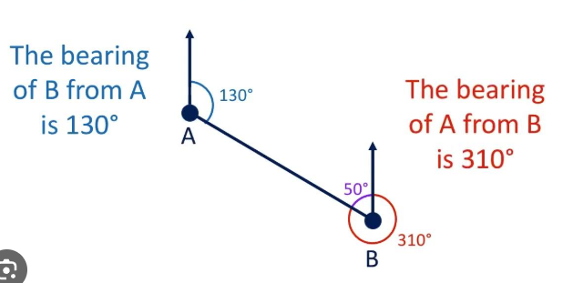

Figure 3.5 Bearing Calculation on a Map from One Place to Another

### 2.6.1 Convert to Degrees

To calculate the bearing between two points in degrees, the geographic coordinates (latitude and longitude) of both points are required. Bearings are measured clockwise from true north and fall within the range of 0° to 360°. The process involves trigonometric calculations using the haversine formula or similar geospatial algorithms. [8]

**Steps to Calculate Bearing in Degrees:**

1. **Define the Coordinates**: Let Point A have coordinates (Lat₁, Lon₁) and Point B have coordinates (Lat₂, Lon₂). These values should be in decimal degrees.
2. **Compute the Angular Difference in Longitude**:



1. **Calculate the Bearing Using the Formula**:

θ = arctan 2 (sin(ΔLon) ⋅ cos(Lat₂), cos(Lat₁) ⋅ sin(Lat₂) − sin(Lat₁) ⋅ cos(Lat₂) ⋅ cos(ΔLon))

Here:

* 1. arctan 2(y, x) is the two-argument arctangent function, which calculates the angle in the correct quadrant.
  2. The input coordinates are converted to radians for trigonometric functions.

1. **Convert the Bearing to Degrees**: The result from the formula is in radians. Convert it to degrees using:

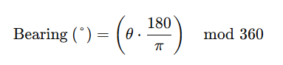

**Example**:

1. Point A: Lat₁ = 34.0522, Lon₁ = -118.2437 (Los Angeles)
2. Point B: Lat₂ = 36.7783, Lon₂ = -119.4179 (Fresno)

Using the above formula, the computed bearing might be approximately **330°**, indicating the direction from Los Angeles to Fresno relative to true north.

### 2.6.2 Convert to Mils

In military contexts, bearings are often expressed in mils, a unit of angular measurement where 1 mil equals 1/6400 of a circle (NATO standard). Mils offer finer precision than degrees, as there are 6400 mils in a full circle compared to 360 degrees.

To convert a bearing in degrees to mils:

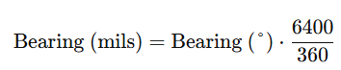

**Steps to Convert Degrees to Mils**:

1. Start with the bearing in degrees obtained from the previous calculation.
2. Multiply the bearing in degrees by the conversion factor **Example**:



If the bearing between two points is **330°**, the equivalent in mils is:

330 ⋅ 17.7778 ≈ 5866 mils

The bearing in mils is approximately **5866**, providing greater precision for military applications. [8]

## 2.7 Map Caching For Online and Offline Use

Map caching is a critical technique in geospatial applications, enabling efficient access to map data and enhancing the performance of mapping systems. By storing pre-rendered or pre-fetched map tiles locally, either temporarily or permanently, map caching ensures seamless user experiences in both online and offline environments. This capability is especially important for applications where consistent access to maps is essential, such as navigation, tactical planning, or field operations, regardless of network availability. [9]

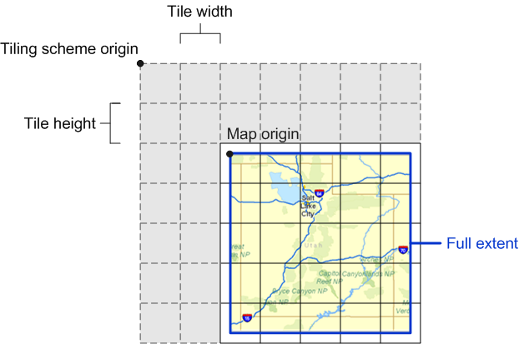

Figure 3.6 Map Caching with tile

### ****2.7.1 Purpose of Map Caching****

1. **Improved Performance**: Map caching reduces the load time of map tiles by serving data from local storage rather than remote servers. This improves responsiveness, especially in environments with limited bandwidth or high latency.
2. **Offline Accessibility**: Offline map caching allows users to access critical map data without requiring an active internet connection, which is invaluable in remote or operationally constrained areas.
3. **Reduced Data Usage**: By reusing cached tiles, map caching minimizes data transfer requirements, lowering costs and conserving bandwidth for users in metered or data-sensitive scenarios.
4. **Scalability**: Caching helps reduce the load on mapping servers, allowing them to serve a larger number of users efficiently during peak times. [9]

### ****2.7.2 Types of Map Caching****

1. **Client-Side Caching**: Map tiles are stored locally on the user's device. This approach is common in mobile applications where users may need offline access to specific map regions.
2. **Server-Side Caching**: Frequently requested map tiles are cached on intermediary servers (e.g., Content Delivery Networks) to accelerate delivery to end-users and reduce server load.
3. **Hybrid Caching**: Combines client-side and server-side caching, leveraging local storage for personalized access while utilizing server caching for general map requests. [9]

### ****2.7.3 Implementation of Map Caching****

1. **Pre-Caching**: In pre-caching, map tiles for specific areas are downloaded and stored before they are needed. For example, users can select a region on a map for offline use, and the application will fetch and store all required tiles for that area.
2. **On-Demand Caching**: In this approach, tiles are cached dynamically as users navigate through the map. Frequently accessed tiles remain stored locally for reuse, reducing the need to re-fetch them from the server.
3. **Storage Management**: Efficient management of storage is crucial for map caching. Strategies include:
   1. Defining a maximum storage size.
   2. Using Least Recently Used (LRU) algorithms to remove outdated tiles.
   3. Allowing users to clear or manage the cache manually.
4. **Data Formats**: Cached tiles are often stored in formats like PNG or JPEG for raster maps or GeoJSON for vector maps. The choice of format impacts storage efficiency and rendering speed. [9]

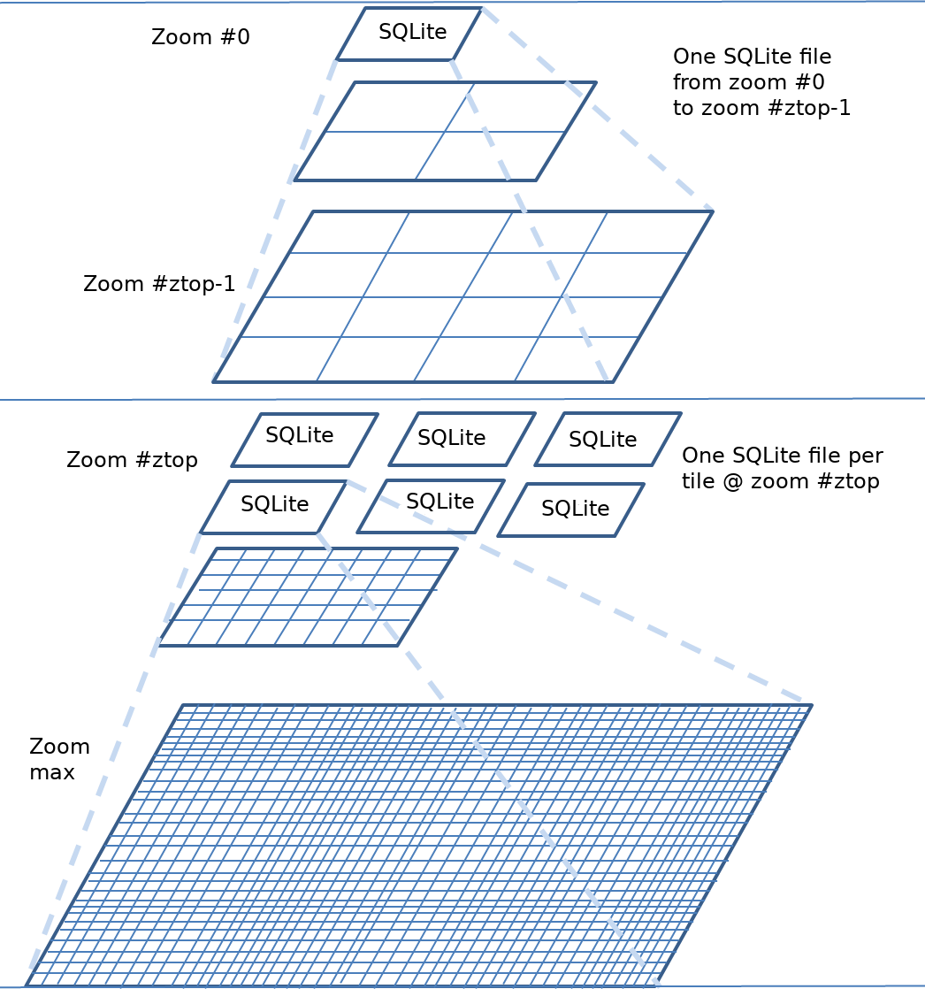

Figure 3.7 **Implementation of Map Caching**

### ****2.7.4** Online **and Offline Use Cases****

1. **Online Use**:
   1. Accelerates map rendering by retrieving tiles from the cache.
   2. Provides fallback options when the server is temporarily unavailable.
2. **Offline Use**:
   1. Essential for navigation apps in remote areas without cellular or internet access.
   2. Ensures military or disaster response teams have uninterrupted access to mission-critical map data in field operations. [9]

### ****2.7.5 Challenges and Solutions****

1. **Storage Constraints**: Mobile devices often have limited storage capacity, making efficient caching strategies crucial. This can be addressed by compressing tiles and implementing storage management policies.
2. **Data Freshness**: Cached maps may become outdated, especially in regions with rapid infrastructure changes. Applications can implement periodic updates or notify users when offline maps need refreshing.
3. **Privacy and Security**: For sensitive operations, cached data must be encrypted and protected to prevent unauthorized access.
4. **Dynamic Content**: Maps with frequently changing data (e.g., traffic or weather layers) require additional strategies to synchronize and update dynamic layers without consuming excessive bandwidth. [9]

### ****2.7.6 Tools and Libraries for Map Caching****

1. **Mobile SDKs**:
   1. Google Maps SDK and Mapbox SDK provide built-in caching mechanisms for offline maps.
   2. Open-source libraries like Leaflet or Tangram allow developers to implement custom caching solutions.
2. **Server Solutions**:
   1. Tools like GeoServer and TileCache enable server-side caching for GIS applications.
   2. Content Delivery Networks (CDNs) like Cloudflare can cache tiles to optimize distribution.
3. **Database Integration**: SQLite or MBTiles formats can be used to store and manage cached tiles efficiently on devices. [9]

## 2.8 Lanchester’s Square Law for decision making Feedback

Lanchester’s Square Law, a mathematical model developed during World War I, provides a quantitative approach to analyzing combat scenarios. It is particularly useful in decision-making for military operations, where understanding the relative effectiveness of opposing forces is critical. The law is based on the principle that the combat power of a force is proportional to the square of its size, assuming that each combatant is equally effective and engages its opponent uniformly. This model aids in evaluating the balance of power, predicting outcomes, and optimizing resource allocation in tactical and strategic planning. [10]

### ****2.8.1 Overview of Lanchester’s Square Law****

Lanchester’s Square Law applies primarily to modern direct-fire combat scenarios, where every combatant can target any member of the opposing force. The law states:

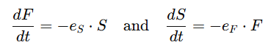

Where:

1. F: The size of Force F (e.g., friendly forces).
2. S: The size of Force S (e.g., enemy forces).
3. eS​: The effectiveness of Force S's firepower.
4. eF​: The effectiveness of Force F's firepower.

The law implies that the force with a numerical and effectiveness advantage can dominate the engagement, as their overall firepower grows quadratically with size. This insight is pivotal for assessing combat readiness and strategic deployment. [11]

### ****2.8.2 Application in Tactical Decision-Making****

1. **Resource Allocation**: Lanchester’s Law is instrumental in determining how to allocate limited resources, such as troops, vehicles, or artillery, to maximize combat effectiveness. By evaluating the relative strengths and weaknesses of opposing forces, commanders can decide on reinforcement priorities or optimal attack strategies.
2. **Simulation and Prediction**: Using the law, decision-makers can simulate various combat scenarios, predict outcomes, and test different strategies under controlled conditions. This enables preemptive adjustments to force composition or tactics before engagement.
3. **Strategic Planning**: The law helps in assessing whether a smaller, more technologically advanced force can counter a numerically superior adversary. This is particularly relevant in modern asymmetrical warfare scenarios, where advanced weaponry and tactics can offset disadvantages in size.
4. **Operational Efficiency**: By quantifying the relative impact of losses on both sides, Lanchester’s Square Law guides commanders in deciding when to escalate, retreat, or hold positions, ensuring optimal utilization of available resources. [11]

## 2.9 Summary

This chapter explored the foundational concepts and technologies essential for developing a military tactical support system. It began by discussing the importance of Flutter for building cross-platform mobile applications, followed by an in-depth analysis of Geographic Information Systems (GIS) and their role in spatial data visualization. The Military Grid Reference System (MGRS) and latitude/longitude conversion techniques were detailed to highlight their relevance in precise geolocation for tactical operations. Bearing calculations in both degrees and mils were explained to enable accurate directional assessments, while the significance of Tactical Decision Support Systems (TDSS) was underscored for informed decision-making in mission-critical scenarios. Finally, the role of map caching for online and offline applications was examined, emphasizing its contribution to seamless navigation and operational efficiency in diverse environments. Together, these components provide the technical foundation for implementing a robust geospatial system to support military operations.

# CHAPTER 3

# SYSTEM DESIGN AND IMPLEMENTATION

This chapter includes the proposed system design, encryption process, decryption process, implementation and results.

## 3.1 Proposed System Design of Android Application

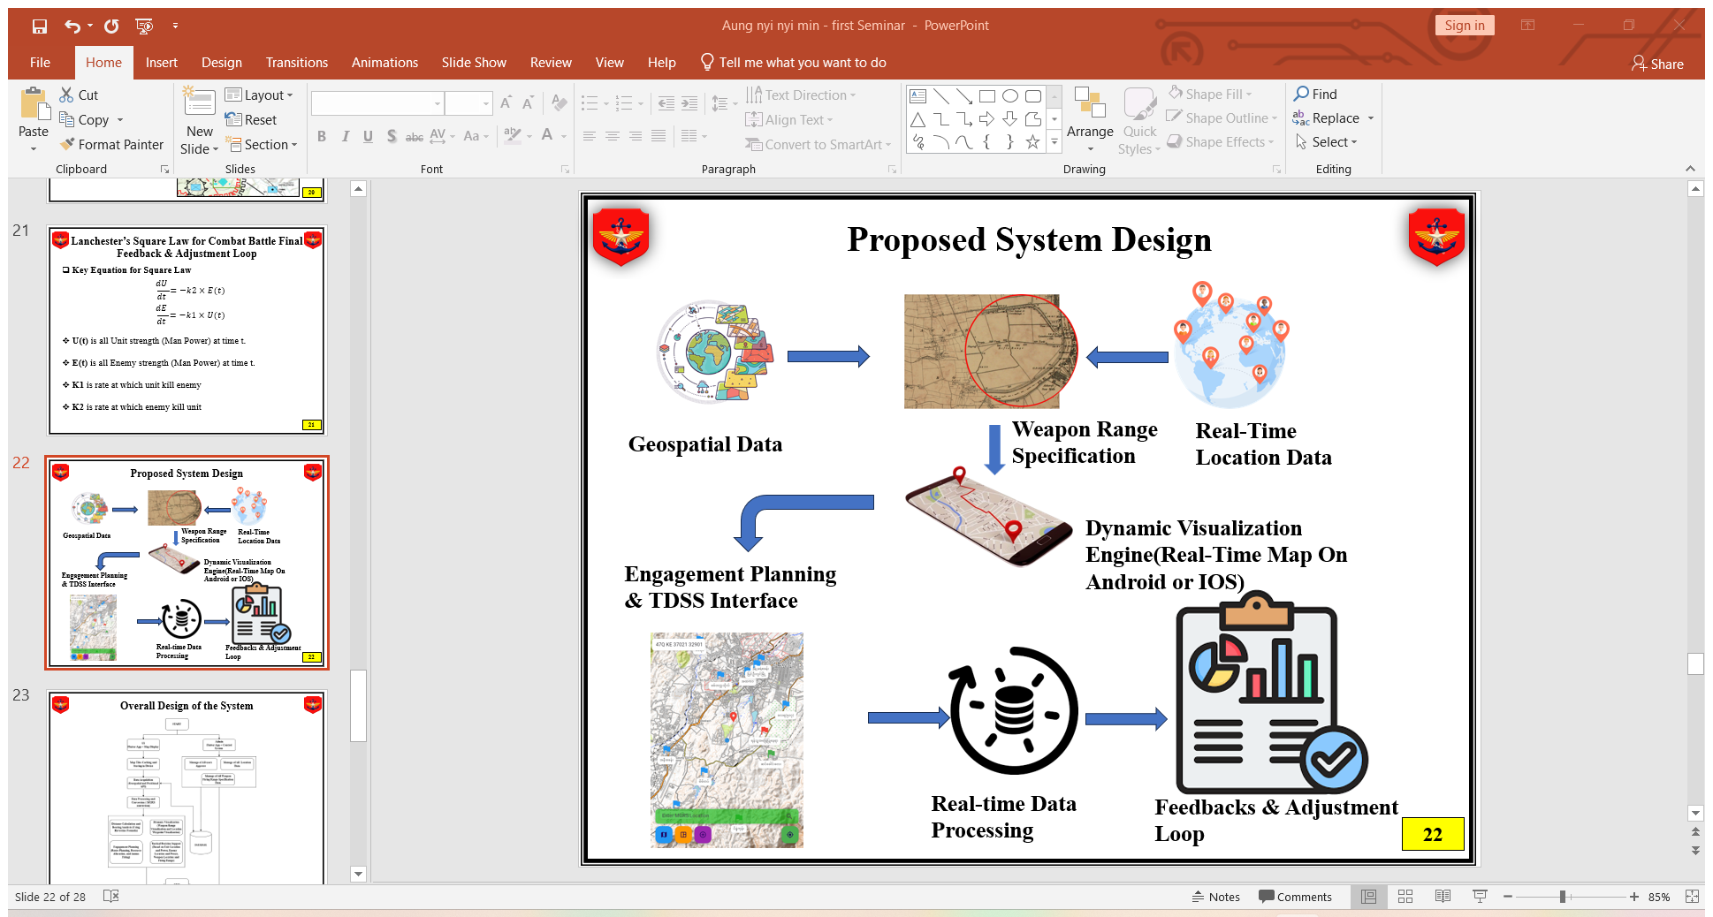

Figure 3.1 Proposed System Design of Android Application

The figure 3.1 illustrates an integrated system framework for automated dynamic weapon range visualization and engagement planning using geospatial data. The workflow begins with geospatial data collection, which serves as the foundation for mapping and situational awareness. Real-time location data is processed alongside weapon range specifications, enabling precise localization of tactical assets. This data is visualized through a dynamic engine that generates interactive real-time maps accessible on Android or iOS platforms. Engagement planning is carried out using a Tactical Decision Support System (TDSS) interface, providing actionable insights and strategic overlays. Real-time data processing ensures the continuous integration of updated inputs, which is fed back into a feedback and adjustment loop. This iterative process enables the refinement of operational strategies and ensures optimal decision-making under dynamic conditions.

## 3.2 Overall Design of the System

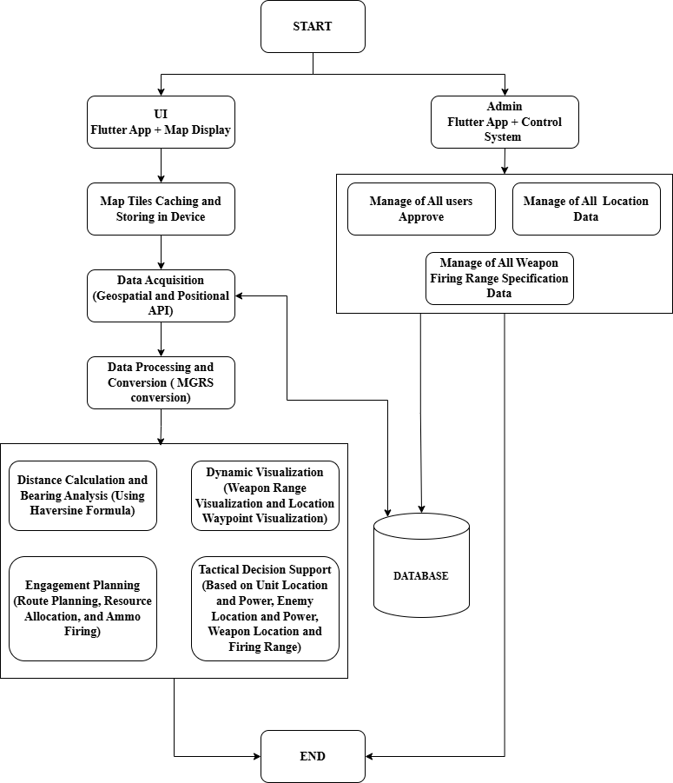

Figure 3.2 Overall Design of the System

The figure 3.2 shows an overall system architecture for implementing an automated dynamic weapon range visualization and engagement planning tool. The process begins with the initialization of the system, which bifurcates into two key modules: the User Interface (UI) on the Flutter app and the Admin Control System. On the UI side, the application starts with a map display and integrates map tile caching for offline usage. Geospatial and positional data are acquired through APIs, which are then processed and converted into the Military Grid Reference System (MGRS). The processed data supports multiple functionalities, including distance and bearing calculations using the Haversine formula, dynamic weapon range and waypoint visualizations, and engagement planning. This module facilitates tactical decision-making by analyzing unit positions, enemy locations, weapon ranges, and resource allocation. On the Admin side, the control system manages critical tasks such as user approvals, location data, and weapon firing range specifications. All data processed by both user and admin modules is stored in a centralized database, ensuring consistency and synchronization. The database serves as the backbone, enabling seamless integration between modules and supporting real-time operations. This structured workflow ensures efficient decision-making and adaptability in military tactical scenarios.

## 3.3 Detail Design for Admin

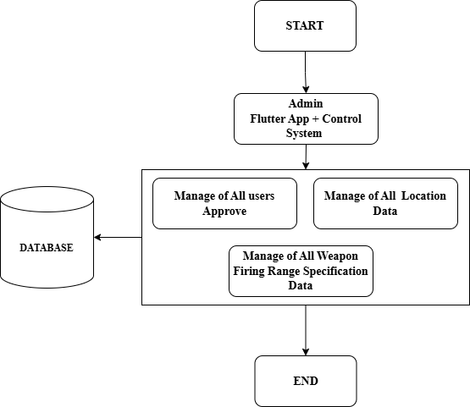

Figure 3.3 Detail Design for Admin

The figure 3.3 shows the administrative module of the system, emphasizing the centralized management of critical operational data. The process begins with the **Admin Flutter App and Control System**, which acts as the primary interface for administrative operations. The system supports three main functionalities: managing user approvals, overseeing location data, and handling weapon firing range specifications. These tasks are synchronized with a central **database**, ensuring data integrity and accessibility. The database stores all user, location, and weapon-related data, facilitating seamless updates and retrieval. This structured flow enables efficient system control, scalability, and secure data management, ensuring that operational parameters align with mission-critical requirements before concluding the administrative cycle.

## 3.4 Detail Design for User

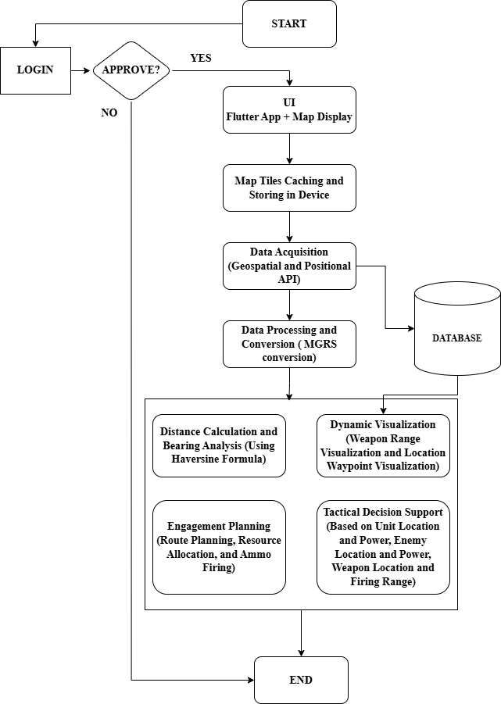

Figure 3.4 Detail Design for User

The figure 3.4 shows a tactical decision support system integrating geospatial data and user interaction. Starting with user login and approval, the process moves to a Flutter-based user interface displaying maps. The system incorporates map tile caching and local storage for offline access, followed by data acquisition via geospatial and positional APIs. The acquired data undergoes processing and conversion to the MGRS (Military Grid Reference System) format, stored in a database. The core functionalities include distance and bearing analysis using the Haversine formula, dynamic visualization of weapon ranges and waypoints, engagement planning (involving route planning, resource allocation, and ammunition firing), and tactical decision support. The system enables strategic planning by leveraging unit locations, enemy positions, weapon capabilities, and firing ranges, culminating in an end-to-end support mechanism.

## 3.5 Proposed System Design for Database

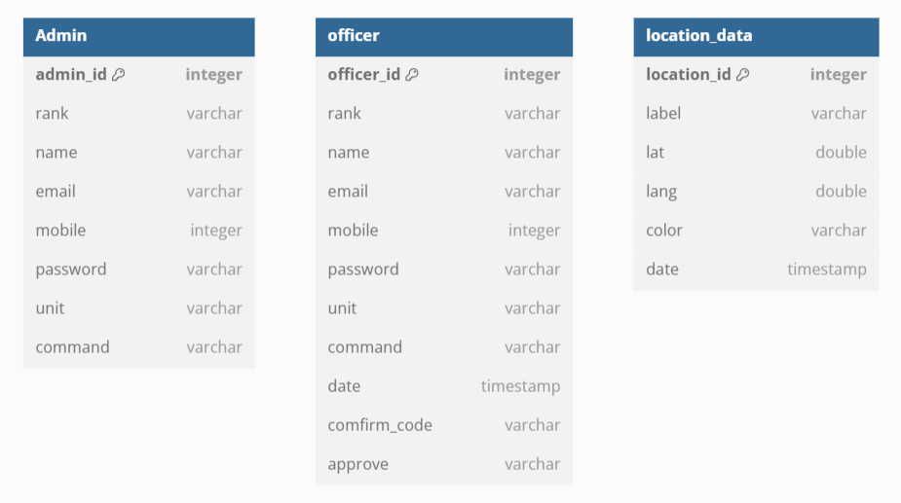

Figure 3.5 Proposed System Design for Database

The figure 3.5 represents the schema of a relational database with three interconnected tables: **Admin**, **Officer**, and **Location_data**, designed to manage personnel and location-related information. The **Admin** table stores details about administrators, including their ID, rank, name, email, mobile number, password, unit, and command authority. Similarly, the **Officer** table tracks officers with similar fields, such as ID, rank, contact information, unit, and command, along with additional fields like date, confirmation codes, and approval status, possibly for access verification. The **Location_data** table captures geographical information with attributes like location ID, label, latitude, longitude, color (likely for visual categorization), and timestamp. This database structure is suitable for an organizational system managing personnel hierarchy and tracking operations or activities across various locations.

## 3.6 Distance Calculation from One Place to Another using Haversine Formula

The Haversine formula is a mathematical equation used to calculate the great-circle distance between two points on the Earth's surface based on their latitude and longitude. It considers the Earth as a sphere, making it highly accurate for most purposes. The formula is expressed as:

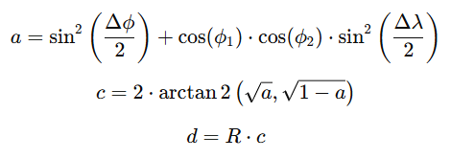

Where:

1. ϕ1, ϕ2 ​: Latitudes of the two points (in radians).
2. Δϕ: Difference in latitudes (ϕ2−ϕ1​).
3. Δλ: Difference in longitudes (λ2−λ1).
4. R: Radius of the Earth (approximately 6371 km).

This formula calculates the shortest distance between two locations along the Earth's surface.

### 3.6.1 Example: Distance Calculation from Pyin Oo Lwin to Mandalay

Let’s compute the distance between **Pyin Oo Lwin** (latitude: 22.0355, longitude: 96.4583) and **Mandalay** (latitude: 21.9759, longitude: 96.0844) using flutter.

double haversineDistance (LatLng point1, LatLng point2) {

    const earthRadiusKm = 6371.0; // Radius of the Earth in kilometers

    final dLat = radians (point2.latitude - point1.latitude);

    final dLon = radians (point2.longitude - point1.longitude);

    final a = pow (sin(dLat / 2), 2) +

        cos(radians(point1.latitude)) *

            cos(radians(point2.latitude)) *

            pow(sin(dLon / 2), 2);

    final c = 2 * atan2(sqrt(a), sqrt(1 - a));

    return earthRadiusKm * c;

  }

## 3.7 Bearing Calculation from One Place to Another

The **bearing** (or azimuth) is the direction from one point on the Earth's surface to another, measured in degrees from the north. It helps determine the angle at which you must travel to move from one location to another. The formula for bearing calculation is as follows:



Where:

1. ϕ1, ϕ2 ​: Latitudes of the two points (in radians).
2. Δλ: Difference in longitudes (λ2−λ1 ​, in radians).
3. θ: The calculated bearing in radians.

Finally, the result is converted to degrees and normalized to a range of 0∘ to 360∘ using:



### 3.7.1 Example: Bearing Calculation from Pyin Oo Lwin to Mandalay

Let’s compute the bearing from **Pyin Oo Lwin** (latitude: 22.0355, longitude: 96.4583) to **Mandalay** (latitude: 21.9759, longitude: 96.0844) using flutter.

/// Calculate the bearing between two points in degrees

  double calculateBearing(LatLng start, LatLng end) {

    final lat1 = degreesToRadians(start.latitude);

    final lon1 = degreesToRadians(start.longitude);

    final lat2 = degreesToRadians(end.latitude);

    final lon2 = degreesToRadians(end.longitude);

    final dLon = lon2 - lon1;

    final x = math.sin(dLon) * math.cos(lat2);

    final y = math.cos(lat1) * math.sin(lat2) -

        math.sin(lat1) * math.cos(lat2) * math.cos(dLon);

    final initialBearing = radiansToDegrees(math.atan2(x, y));

    return (initialBearing + 360) % 360; // Normalize to 0-360 degrees

  }

  /// Convert degrees to radians

  double degreesToRadians(double degrees) {

    return degrees * (math.pi / 180.0);

  }

  /// Convert radians to degrees

  double radiansToDegrees(double radians) {

    return radians * (180.0 / math.pi);

  }

## 3.8 Weapon Firing Solutions for Two Motor Guns (MA-7, MA-8)

To calculate weapon firing solutions for two motor guns (MA-7 and MA- 8), we need to determine key parameters such as bullet flight time, gun power, and long-distance capabilities at a specific range (e.g., 2000 meters). These calculations will help us understand how each weapon performs at a given distance.

### 3.8.1. General Formula for Firing Solutions

1. Bullet Flight Time Calculation: The bullet flight time decreases linearly with the increase in range within specific intervals. The formula for bullet flight time can be defined as:

Bullet Flight Time = Initial Time - (Range - Min Range/ Max Range - MinRange) × (Initial Time - Final Time)

1. Long Distance Calculation: The long-distance value decreases linearly with the range within defined intervals. The formula is:

Long Distance = Initial Distance - (Range - Min Range /Max Range - Min Range) × (Initial Distance - Final Distance)

1. Gun Power Calculation: Gun power is assigned based on specific range intervals and typically increases as the range increases.

### 3.8.1. Example Calculations for 2000 Meters for MA-7

Given range: 2000 meters

1. Gun Power: For the **MA-7**, the gun power at **2000 meters** falls within the range of **1550 meters to 2150 meters**. Based on the context, if the gun power is assigned a specific value for this range, it is given as **2**.
2. Bullet Flight Time: To calculate the **bullet flight time** at a specific distance, interpolation is performed between the known times at 1550 meters and 2150 meters using the following formula:

Bullet Flight Time = Initial Time - (Range - Min Range/ Max Range - MinRange) × (Initial Time - Final Time)

1. Calculation:
2. **Initial Bullet Flight Time at 1550m:** 25.9 seconds
3. **Final Bullet Flight Time at 2150m**: 18.6 seconds
4. **Distance (D)**: 2000 meters2000
5. Plugging into the formula:

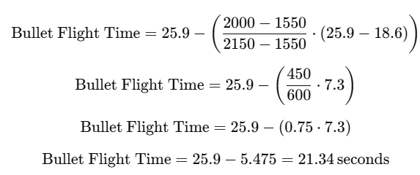

Thus, the **bullet flight time at 2000 meters** is **21.34 seconds**.

1. Long Distance: Using the **long-distance calculation formula**, we analyze the given initial value.
2. **Initial Long Distance at 1550m**: 1213 meters

Further calculations depend on the formula, which seems incomplete. If additional values or relationships for the distances at 2000m and 2150m are given, those could be used to extend this calculation.

### 3.8.1. Example Calculations for 2000 Meters for MA-7 in Flutter

// Generate MA7 weapons

final List<Weapon> ma7Weapons = List.generate(4351, (index) {

  double range = 250 + index.toDouble();

  double gunPower = 0.0;

  double bulletFlightTime = 0.0;

  double longDistance = 0.0;

  if (range >= 250 && range <= 750) {

    gunPower = 0;

  } else if (range > 750 && range <= 1550) {

    gunPower = 1;

  } else if (range > 1550 && range <= 2150) {

    gunPower = 2;

  } else if (range > 2150 && range <= 2900) {

    gunPower = 3;

  } else if (range > 2900 && range <= 3480) {

    gunPower = 4;

  } else if (range > 3480 && range <= 4050) {

    gunPower = 5;

  } else if (range > 4050 && range <= 4600) {

    gunPower = 6;

  }

  bulletFlightTime = calculateBulletFlightTimeMA7(range, gunPower);

  longDistance = calculateLongDistanceMA7(range);

  return Weapon(

    name: 'MA7',

    range: range,

    gunPower: gunPower,

    bulletFlightTime: bulletFlightTime,

    longDistance: longDistance,

    id: index,

  );

});

## 3.9 Latitude/ Longitude Coordinate to MGRS Conversion

Here is a high-level breakdown of the conversion process:

1. **Understand the MGRS System**: The Earth is divided into **60 longitudinal zones**, each 6° wide. Each longitudinal zone is further divided into **20 latitude bands**, each 8° high (except near the poles). Zones and latitude bands are identified by numbers (1-60 for zones) and letters (C-X for latitude bands, skipping I and O).
2. **Steps of Conversion**:
3. **Identify the UTM Zone**: UTM (Universal Transverse Mercator) divides the Earth into zones based on longitude. Determine the zone number:

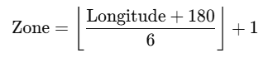

1. Latitude determines the latitude band (e.g., C, D, ..., X).
2. **Project Latitude/Longitude to UTM Coordinates**: Convert the latitude and longitude into UTM coordinates using the Transverse Mercator projection: Apply the Transverse Mercator formula to calculate **easting** and **northing** (distances from the central meridian and equator).
3. **Divide into 100,000m Grid Squares**: UTM coordinates are divided into 100,000m grid squares with specific two-letter identifiers.
4. **Truncate UTM Coordinates to Precision**: Depending on desired precision (1m, 10m, 100m, etc.), truncate the easting and northing values accordingly.
5. **Assemble the MGRS String**: Combine the zone number, latitude band, two-letter grid square ID, and the truncated easting/northing values.

### 3.9.1 Latitude/ Longitude Coordinate to MGRS Conversion in Flutter

class MGRS {

  static final List<String> zoneLetters = [

    'C','D','E','F','G','H','J','K','L','M','N','P','Q','R','S','T','U','V', 'W','X'

  ];

  static final List<String> e100kLetters = ['ABCDEFGH', 'JKLMNPQR', 'STUVWXYZ'];

  static final List<String> n100kLetters = [

    'ABCDEFGHJKLMNPQRSTUV',

    'FGHJKLMNPQRSTUVABCDE'

  ];

  static String latLonToMGRS(double lat, double lon) {

    if (lat < -80) return 'Too far South';

    if (lat > 84) return 'Too far North';

    int zoneNumber = ((lon + 180) / 6).floor() + 1;

    double e = zoneNumber * 6 - 183;

    double latRad = lat * (pi / 180);

    double lonRad = lon * (pi / 180);

    double centralMeridianRad = e * (pi / 180);

    double cosLat = cos(latRad);

    double sinLat = sin(latRad);

    double tanLat = tan(latRad);

    double tanLat2 = tanLat * tanLat;

    double tanLat4 = tanLat2 * tanLat2;

    double tanLat6 = tanLat2 * tanLat4;

    double o = 0.006739496819936062 * cosLat * cosLat;

    double p = 40680631590769 / (6356752.314 * sqrt(1 + o));

    double t = lonRad - centralMeridianRad;

    double N = 6378137.0 / sqrt(1 - 0.00669438 * sinLat * sinLat);

    double T = tanLat2;

    double C = 0.006739496819936062 * cosLat * cosLat;

    double A = cosLat * (lonRad - centralMeridianRad);

    double M = 6367449.14570093 *

        (latRad -

            (0.00251882794504 * sin(2 * latRad)) +

            (0.00000264354112 * sin(4 * latRad)) -

            (0.00000000345262 * sin(6 * latRad)) +

            (0.000000000004892 * sin(8 * latRad)));

    double x = (A +

            (1 - T + C) * A * A * A / 6 +

            (5 - 18 * T + T * T + 72 * C - 58 * 0.006739496819936062) *

                A *

                A *

                A *

                A *

                A /

                120) *

        N;

    double y = (M +

            N *

                tanLat *

                (A * A / 2 +

                    (5 - T + 9 * C + 4 * C * C) * A * A * A * A / 24 +

                    (61 -

                            58 * T +

                            T * T +

                            600 * C -

                            330 * 0.006739496819936062) *

                        A *

                        A *

                        A *

                        A *

                        A *

                        A /

                        720)) *

        0.9996;

    x = x * 0.9996 + 500000.0;

    y = y * 0.9996;

    if (y < 0.0) {

      y += 10000000.0;

    }

    double aa = p * cosLat * t +

        (p / 6.0 * pow(cosLat, 3) * (1.0 - tanLat2 + o) * pow(t, 3)) +

        (p /

            120.0 *

            pow(cosLat, 5) *

            (5.0 - 18.0 * tanLat2 + tanLat4 + 14.0 * o - 58.0 * tanLat2 * o) *

            pow(t, 5)) +

        (p /

            5040.0 *

            pow(cosLat, 7) *

            (61.0 - 479.0 * tanLat2 + 179.0 * tanLat4 - tanLat6) *

            pow(t, 7));

    double ab = 6367449.14570093 *

            (latRad -

                (0.00251882794504 * sin(2 * latRad)) +

                (0.00000264354112 * sin(4 * latRad)) -

                (0.00000000345262 * sin(6 * latRad)) +

                (0.000000000004892 * sin(8 * latRad))) +

        (tanLat / 2.0 * p * cosLat * cosLat * t * t) +

        (tanLat /

            24.0 *

            p *

            pow(cosLat, 4) *

            (5.0 - tanLat2 + 9.0 * o + 4.0 * o * o) *

            pow(t, 4)) +

        (tanLat /

            720.0 *

            p *

            pow(cosLat, 6) *

            (61.0 -

                58.0 * tanLat2 +

                tanLat4 +

                270.0 * o -

                330.0 * tanLat2 * o) *

            pow(t, 6)) +

        (tanLat /

            40320.0 *

            p *

            pow(cosLat, 8) *

            (1385.0 - 3111.0 * tanLat2 + 543.0 * tanLat4 - tanLat6) *

            pow(t, 8));

    aa = aa * 0.9996 + 500000.0;

    ab = ab * 0.9996;

    if (ab < 0.0) ab += 10000000.0;

    String zoneLetter = 'CDEFGHJKLMNPQRSTUVWXX'

        .substring((lat / 8 + 10).floor(), (lat / 8 + 10).floor() + 1);

    int e100kIndex = (aa ~/ 100000);

    String e100kLetter = [

      'ABCDEFGH',

      'JKLMNPQR',

      'STUVWXYZ'

    ][(zoneNumber - 1) % 3][e100kIndex - 1];

    int n100kIndex = (ab ~/ 100000) % 20;

    String n100kLetter = [

      'ABCDEFGHJKLMNPQRSTUV',

      'FGHJKLMNPQRSTUVABCDE'

    ][(zoneNumber - 1) % 2][n100kIndex];

    String easting = x.round().toString().padLeft(6, '0');

    easting = easting.substring(

        1, 6); // Remove the first character, keep the next 5 characters

    // Convert easting back to an integer, sum with 300, and convert back to a string

    easting = (int.parse(easting) + 350).toString().padLeft(5, '0');

    // Convert y to a string, pad it to at least 7 characters, and remove the first 2 characters

    String northing = y.round().toString().padLeft(7, '0');

    northing = northing.substring(

        2, 7); // Remove the first 2 characters, keep the next 5 characters

    // Convert northing back to an integer, sum with 300, and convert back to a string

    northing = (int.parse(northing) + 700).toString().padLeft(5, '0');

    return '$zoneNumber$zoneLetter $e100kLetter$n100kLetter $easting $northing';

  }

## 3.10 Implementation

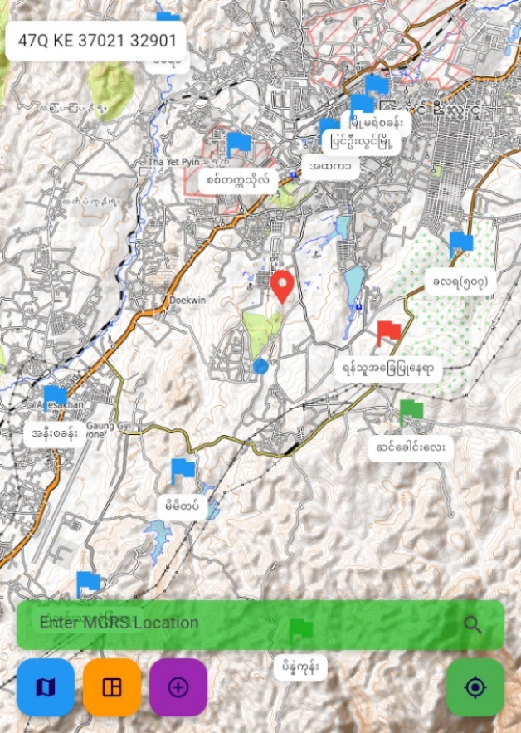

Figure 3.6 Map Integration for User and Admin with OpenTopo Map

Figure 3.6 illustrates the integration of a map interface for both users and administrators using OpenTopo Map, showcasing various marked locations and allowing the input of MGRS coordinates for navigation and interaction.

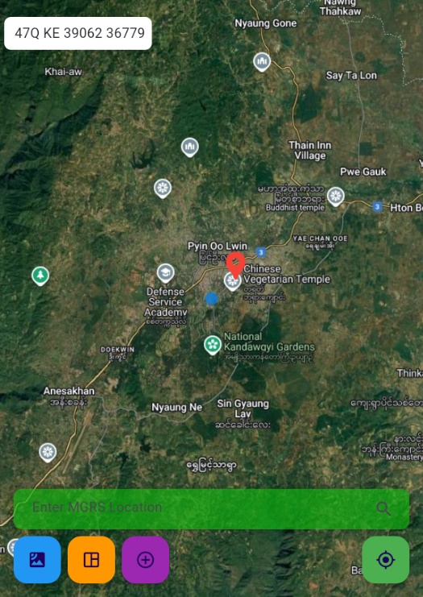

Figure 3.7 Map Integration for User and Admin with Google Hybrid Map

Figure 3.7 illustrates the integration of a map interface for both users and administrators using OpenTopo Map, showcasing various marked locations and allowing the input of MGRS coordinates for navigation and interaction.

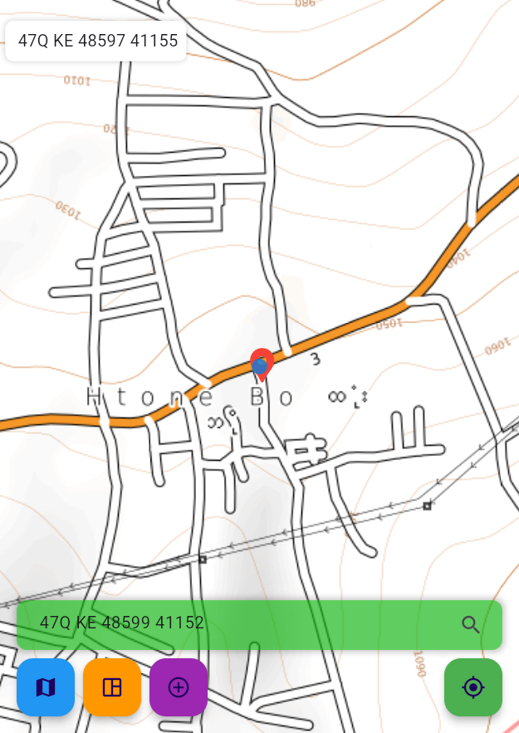

Figure 3.8 Search Locations by MGRS Format

Figure 3.8 illustrates a feature that allows users to search for specific locations using the MGRS (Military Grid Reference System) format, as shown on a detailed map interface

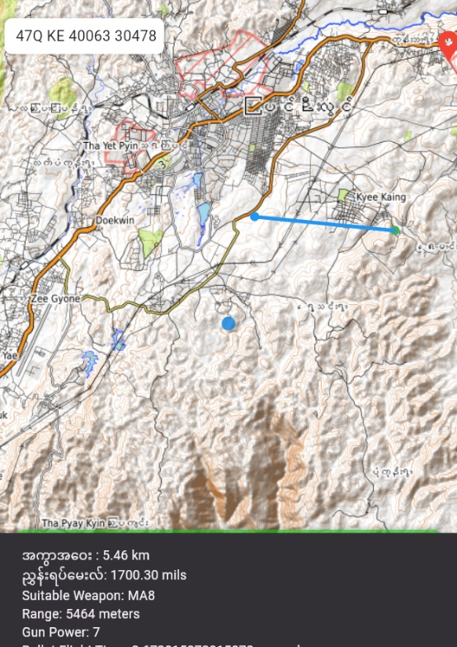

Figure 3.9 Calculate Distance, Bearing and Suitable Weapon for Set Target Two Points

Figure 3.9 illustrates a map-based application calculating the distance, bearing, and a suitable weapon (e.g., MA8) for a set target between two points, providing essential details such as the range and gun power.

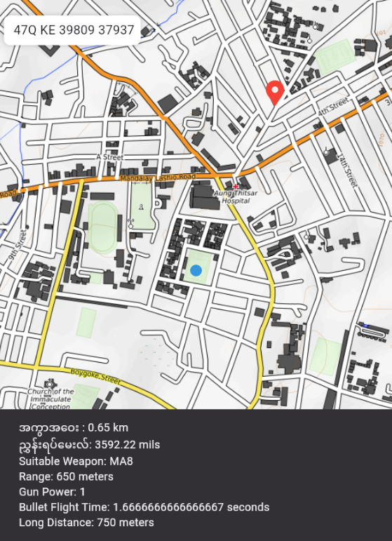

Figure 3.10 Calculate Distance, Bearing and Suitable Weapon from Current Location to Center Point

Figure 3.10 illustrates a map-based application calculating the distance, bearing, and suitable weapon (e.g., based on range and gun power) for a target from the user's current location.

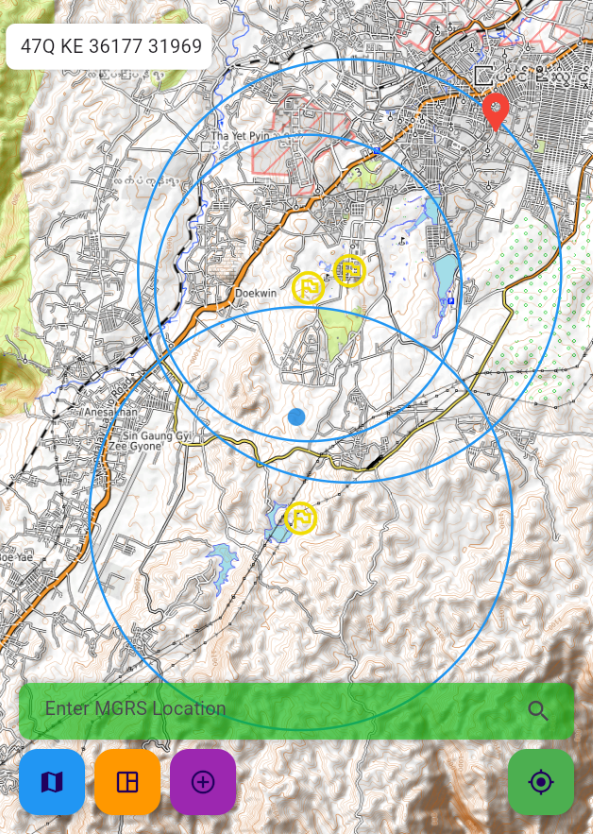

Figure 3.11 Draw Firing range for motor guns on map

Figure 3.11 illustrates a map-based application displaying the firing ranges of mortar guns as concentric circles, visually indicating their effective coverage areas around designated points.

## 3.11 Summary

In Chapter 3, the implementation of an automated dynamic weapon range visualization and engagement planning system for a military tactical support system using geospatial data was detailed. The chapter outlined the core functionalities of the system, including distance and bearing calculations, identification of suitable weapons based on range and firepower, and real-time visualization of firing ranges on geospatial maps. The system integrates features such as MGRS (Military Grid Reference System) location input, target setting, and visualization of firing zones for various weapon systems like mortars and artillery. These features enable precise tactical planning and enhanced situational awareness by leveraging geospatial data to optimize weapon deployment and engagement strategies. The integration of these tools provides a user-friendly and efficient interface for military operations.

# CHAPTER 4

# CONCLUSION

The implementation of an automated dynamic weapon range visualization and engagement planning system represents a significant advancement in modern military tactical support systems. By leveraging geospatial data, the system provides precise distance and bearing calculations, identifies suitable weapons based on operational parameters, and dynamically visualizes firing ranges on a map. This integration not only enhances situational awareness but also facilitates informed decision-making in real-time scenarios. The ability to visualize weapon ranges and engage targets with accuracy empowers military commanders to strategize more effectively, reducing response times and improving mission outcomes.

The system's user-friendly interface, combined with robust geospatial data integration, demonstrates its practical applicability in complex operational environments. Features such as MGRS location input, multi-weapon selection, and dynamic range visualization offer versatility and adaptability for various tactical scenarios. This research highlights the potential of geospatial technologies in advancing military applications and provides a foundation for further innovations in automated decision support systems. By bridging the gap between technology and tactical operations, this system contributes to the modernization of military planning and engagement strategies.

## 4.1 Benefits of the System

The benefits of the proposed system are described as follows:

1. The system provides precise distance and bearing calculations, enabling commanders to make informed decisions in real-time operational scenarios.
2. By identifying suitable weapons based on range, firepower, and target location, the system ensures optimal weapon utilization, minimizing wastage of resources and maximizing effectiveness.
3. The system offers real-time, map-based visualization of weapon ranges, allowing users to analyze coverage areas and plan engagements effectively.
4. The ability to input MGRS coordinates and visualize multiple weapon ranges helps streamline resource allocation and deployment, enhancing operational efficiency.
5. By integrating geospatial data, the system provides a comprehensive overview of the battlefield, enabling users to anticipate threats and plan strategies more effectively.
6. The system’s intuitive design simplifies complex calculations and data visualization, making it accessible to users with varying levels of technical expertise.

## 4.2 Limitations of the System

This system has a few limitations, describes as below;

1. **Dependency on Geospatial Data Accuracy:** The system's performance heavily relies on the accuracy and resolution of the geospatial data. Errors or outdated maps could lead to inaccurate calculations and suboptimal tactical decisions.
2. **Limited Offline Functionality:** While the system supports offline map tiles, certain features, such as live data updates and online map integration, are restricted when an internet connection is unavailable.
3. **Scalability Challenges:** The system may face challenges in managing a high volume of data or accommodating large-scale operations involving multiple units and weapon types.
4. **Complex Environmental Factors:** The system does not account for dynamic environmental factors such as terrain elevation, weather conditions, or obstacles, which may impact the accuracy of weapon range and target engagement.
5. **Limited Weapon Database:** The system depends on a predefined database of weapon specifications. It may not accommodate all available weapons or accurately model newly developed weapon systems without manual updates.
6. **Potential User Dependency:** Over-reliance on the system could reduce the ability of users to make decisions manually, which may pose a risk in situations where the system is unavailable or malfunctioning.

## 4.3 Further Extensions

The proposed system can be further enhanced with the following extensions:

1. **Integration of Environmental Factors:** Incorporating dynamic environmental data such as terrain elevation, weather conditions, and obstacles can improve the accuracy of range calculations and engagement planning.
2. **Real-Time Collaboration:** Adding a multi-user collaboration feature would allow multiple commanders to share tactical data and coordinate operations more effectively in real time.
3. **Advanced Weapon Database:** Expanding the weapon database to include newly developed and experimental weapon systems, along with real-time updates, would enhance the system’s applicability in modern military scenarios.
4. **3D Terrain Visualization:** Introducing 3D visualization of terrain and weapon firing paths can provide more realistic and comprehensive battlefield insights for tactical planning.
5. **Artificial Intelligence Integration:** Implementing AI algorithms for predictive analysis, such as suggesting optimal weapon placements or engagement strategies based on historical data, can further enhance decision-making.
6. **Augmented Reality (AR) Support:** Adding AR capabilities would enable users to visualize weapon ranges and engagement plans directly overlaid on the physical battlefield using AR devices.
7. **Enhanced Offline Features:** Developing a more robust offline mode that includes local computation of complex data and advanced mapping functionalities would increase the system’s reliability in remote or disconnected environments.
8. **Cross-Platform Support:** Extending the system’s compatibility to integrate seamlessly with other military systems, devices, or platforms can broaden its usability and operational scope.

# REFERENCES

[1] Madhuri, R., & Radhakrishnan, M. (2020). Flutter: A Modern Framework for Cross-Platform Mobile Application Development. International Journal of Computer Applications, 175(9), 10-14.

[2] <https://education.nationalgeographic.org/resource/geographic> -information - system-gis/.

[3] El-Gohary, M., & El-Rabbany, A. (2011). Applications of Geographic Information Systems (GIS) in Military Operations. In Proceedings of the 2011 International Conference on Military Communications and Information Systems (ICMCIS) (pp. 1-6). IEEE. <https://doi.org/10.1109/> ICMCIS.2011.5970145.

[4] U.S. Department of Defense (2019). Geospatial Intelligence: A Guide for Military Applications. Department of Defense, Washington, D.C.

[5] Karney, C. F. F. (2011). Transverse Mercator with an accuracy of a few nanometers. Journal of Geodesy, 85(8), 475–485. <https://doi.org/10.1007/> s00190-011-0445-3.

[6] Defense Mapping Agency, Technical Manual 8358.1: Datums, Ellipsoids, Grids, and Grid Reference Systems, 1989.

[7] Hale, M., & Davis, R. (2020). The Role of Tactical Decision Support Systems in Modern Warfare. Defense Technology Journal, 14(3), 213-225. https://doi.org/10.1016/j.deftech.2020.01.012

[8] NATO Standardization Office. (2017). Glossary of Terms and Definitions (AAP-06). Retrieved from https://www.nato.int/docu/standard.htm

[9] Huang, B., & Liu, N. (2018). Advances in Mobile Map Caching for Seamless Navigation. Journal of Location-Based Services, 12(2), 89–102. https://doi.org/10.1080/17489725.2018.1435534

[10] Epstein, J. M. (1985). *The Calculus of Conventional War: Dynamic Analysis Without Lanchester Theory*. Brookings Institution.

[11] Tolk, A., Diallo, S. Y., & Wang, W. (2013). *Modeling and Simulation Support for System of Systems Engineering Applications*. Wiley. https://doi.org/10.1002/9781118555922

# APPENDIX/APPENDICES